A1334-ME-Anatolia-Nevali_Cori-Figurine-Conglomerate-8550-6750 BCE

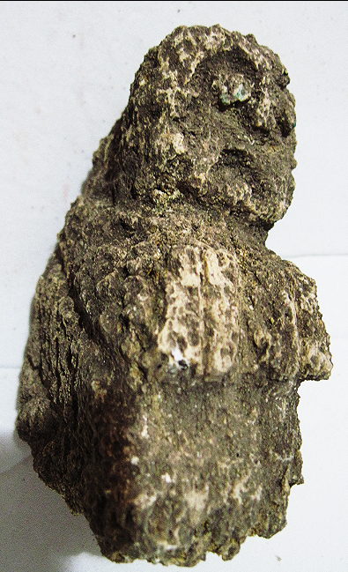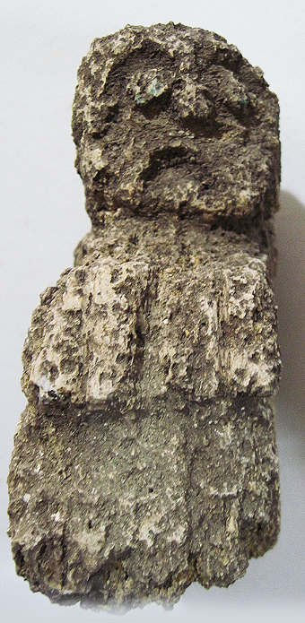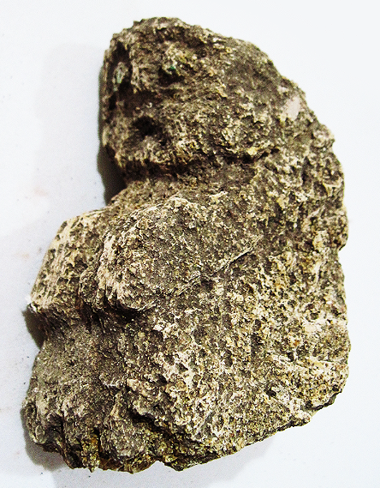

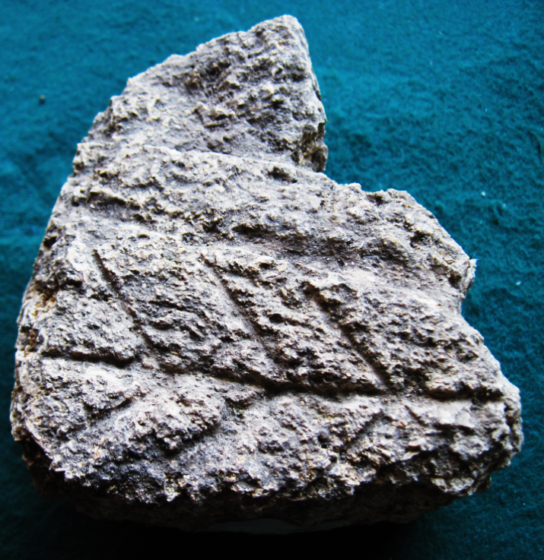 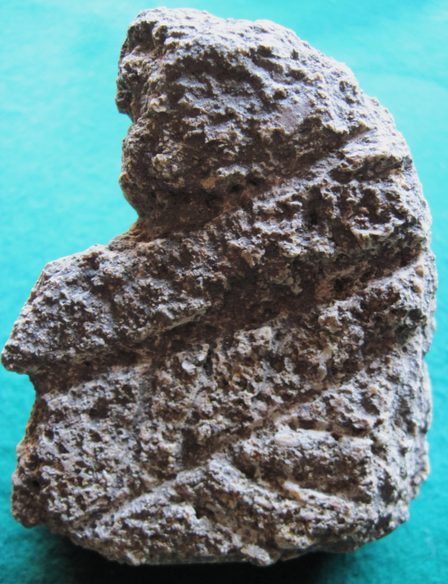

Figs. 1-5. Anatolia-Nevali_Cori-Figurine-Conglomerate-8550-6750 BCE.

Case no.: 3

Accession Number: A1334.

Formal Label: Anatolia-Nevali_Cori-Figurine-Conglomerate-8550-6750 BCE

Display Description:

This figurine is unique among the pieces of the Neolithic sculpture. It has a triangular shape in the silhouette of a seated human figure which has wide-open eyes, a prominent nose, downturned mouth and both arms extended forward with the hands holding the knees possibly in a birthing posture.

This figurine was carved from a piece of conglomerate, which rendered the surface very uneven so the sculptor managed a triangular and slightly thick shape, as if it were a steatopygic figure in relief. The deeply incised lines on the sides suggest a primitive script. For instance, the three asterisks on the right side suggest the well-known Dinger symbol in Akkadian that indicates a divine being. The left side has a more complex series of incisions but the most forward one is an asterisk as well.

Steatopygic figures were revered in a vast and varied region ranging from the Near East to Anatolia to Central Europe, but stone examples are rare and are associated with the Pre-Pottery Neolithic B (PPNB) that was first identified at Jericho in the southern Levant region and dated to 8,700 – 6,000 BCE. This piece dates to PPBN 8550-6750 BCE.

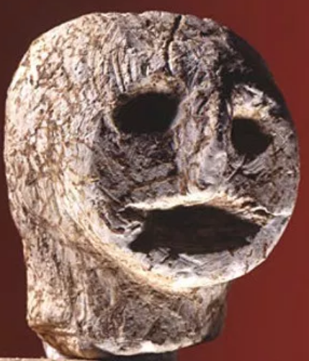 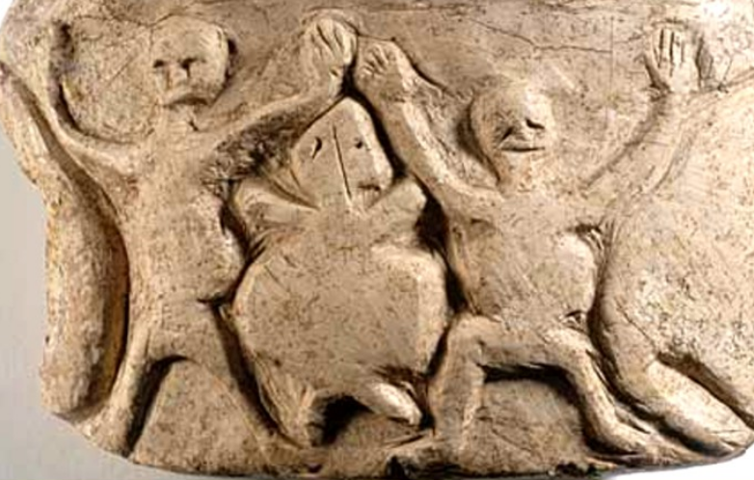

Fig. 6. Limestone head from Nevali Çori after <https://i2.wp.com/realhistoryww.com/world_history/ancient/Images_Anatolia/Nevali_Cori_3.jpg?zoom=2>

Fig. 7. Pregnant women from a terracotta plaque from Nevali Çori from http://realhistoryww.com/world_history/ancient/Images_Anatolia/Nevali_Cori.jpg

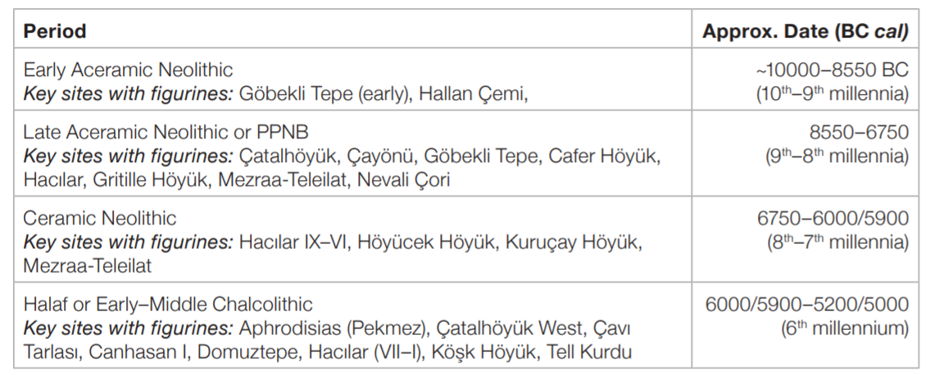 Table 1. Chronology and periods of main sites with published figurine data from Belcher and Croucher 2014.

**LC Classification:** GN855.T83

**Date or Time Horizon:** PPBN 8550-6750 BCE

**Geographical Area:** Southeast Anatolia, possibly Nevali_Cori.

**Map, GPS coordinates**: 37.518333, 38.605556; 37° 31′ 6″ N, 38° 36′ 20″ E

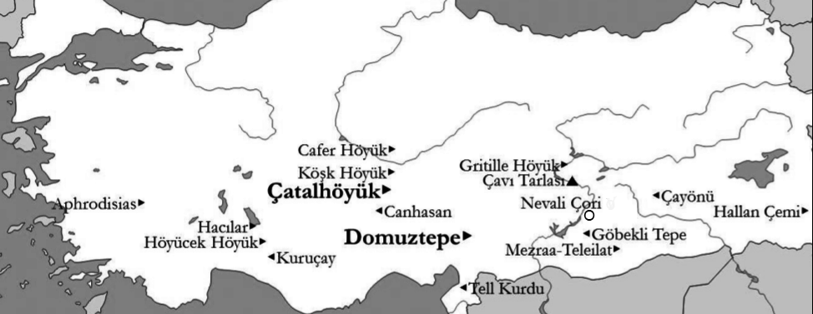

Fig. 8. Map of Anatolia showing key sites of published prehistoric figurine data. From Belcher and Croucher 2014.

**Cultural Affiliation:** Pre Pottery Neolithic B (PPNB)

**Medium:** conglomerate

**Dimensions:** H 107.02 mm; 4.21 in

**Weight: 465 gm; 1 lb 3.8 oz**

**Condition: original**

**Provenance:** unknown

**Discussion:**

PPNB culture developed from the Earlier Natufian culture and shows evidence of a northerly origin, from northeastern Anatolia, perhaps Nevalı Çori, about 490 m above sea level, in the foothills of the Taurus Mountains on both banks of the Kantara stream, a tributary of the Euphrates, SE Anatolia. Nevalı Çori, has some of the world's oldest known temples and monumental sculpture, and together with Göbekli Tepe, PPNB has been extended 2000-3000 years, and the oldest domesticated Einkorn wheat was found there (Haldorsen 2011). Around 11600 cal. b.p., the Younger Dryas climatic period ended and rapid climatic amelioration ensued in the Early Holocene, enabling grasses to spread throughout the region. Ritual PPNA/PPNB sites Göbekli Tepe and Nevali Çori and Çayönü were established at this time with Nevali Çori and Cafer Höyük being the oldest domesticated Einkorn wheat sites yet discovered dating to 10,400 cal. b.p. Although these settlements continued to practice a mixed lifestyle as hunter-gatherers, farmers domesticated Einkorn and populations began to expand.

With this population expansion issues of increased pregnancies may have occasioned the production of figurines such as the current example to be used as votaries for a safe childbirth. Local limestone and conglomerate was carved into numerous statuettes and statues, some with a definite child-birthing theme and some were produced in clay before clay was used for pottery in the PPNB.

**References:**

Balkan-Atli, Nur. 1994. *La néolithisation de l'Anatolie*. Varia anatolica ; 7. Istanbul: Institut français d'études anatoliennes; Paris: De Bocccard.

Belcher, Ellen and Karina Croucher. 2014. “Exchanges of Identity in Prehistoric Anatolian Figurines,” *Proceedings, 9th ICAANE, Basel*, 1: 43–56.

Haldorsen, S. et al. 2011. “The climate of the Younger Dryas as a boundary for Einkorn domestication,” *Veget. Hist. Archaeobotany* 20: 305.

Yakar, Jak. 1991. *Prehistoric Anatolia: the Neolithic transformation and the early Chalcolithic period.* Monograph series (Makhon le-arkheʼologyah ʻa. sh. Sonyah u-Marḳo Nadler); no. 9. Tel Aviv: Institute of Archaeology of Tel Aviv University, Publications Section.